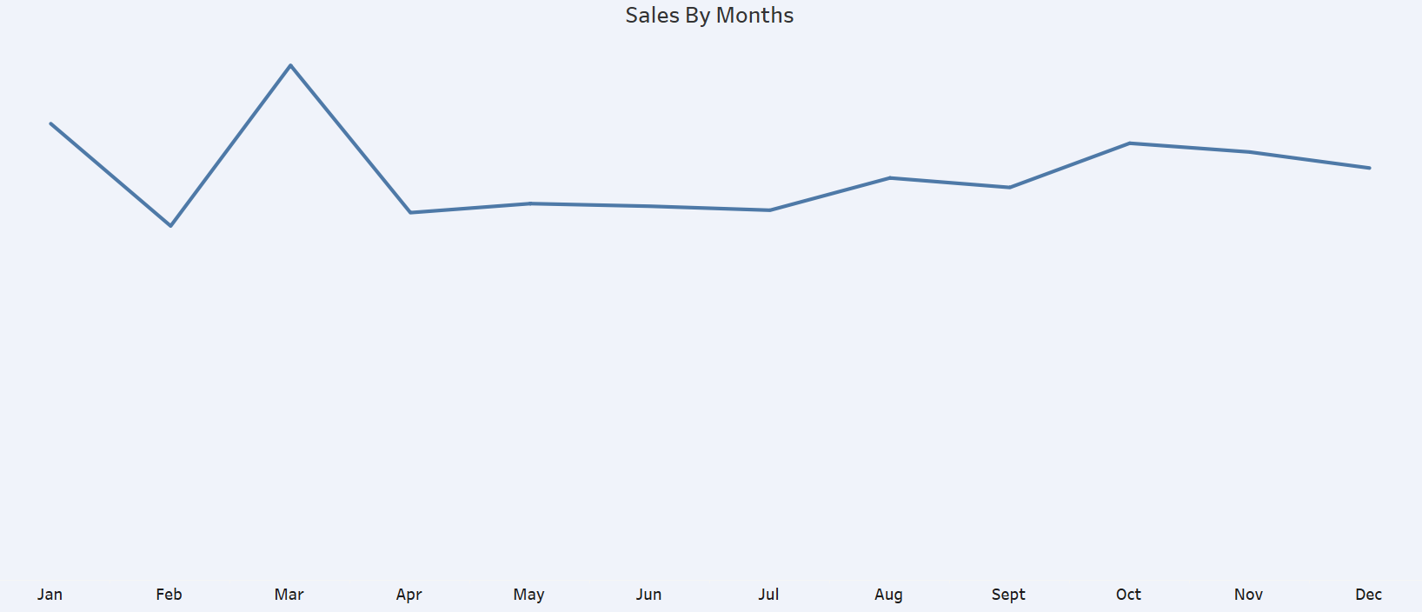

### ****Sales by Months (Line Chart)****

**Observation:** Sales peaked sharply in **March** after a dip in **February**. Post-March, the trend remained relatively stable with minor fluctuations.

**Insight:** There may have been a **campaign, seasonal event, or product launch** in March that drove a sales spike. A review of promotions during that period could reveal replicable strategies.

**Actionable Tip:** Investigate the cause of high sales in March and consider replicating similar initiatives in slower months like **February** or **July**.

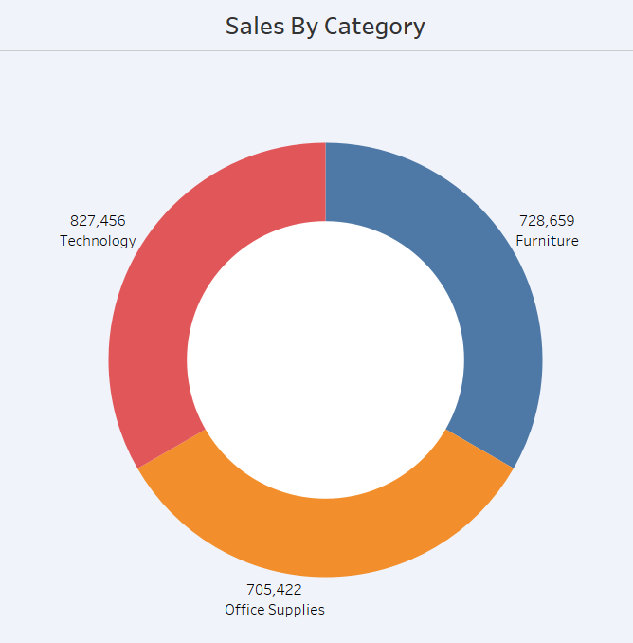

### ****Sales by Category (Donut Chart)****

**Technology** leads with **827,456**, followed by **Furniture** (**728,659**) and **Office Supplies** (**705,422**).

**Insight:** All three categories are performing strongly, but **Technology** stands out as the top contributor.

**Actionable Tip:** Prioritize **Technology category marketing** and ensure adequate inventory and logistics support to maintain and grow this lead.

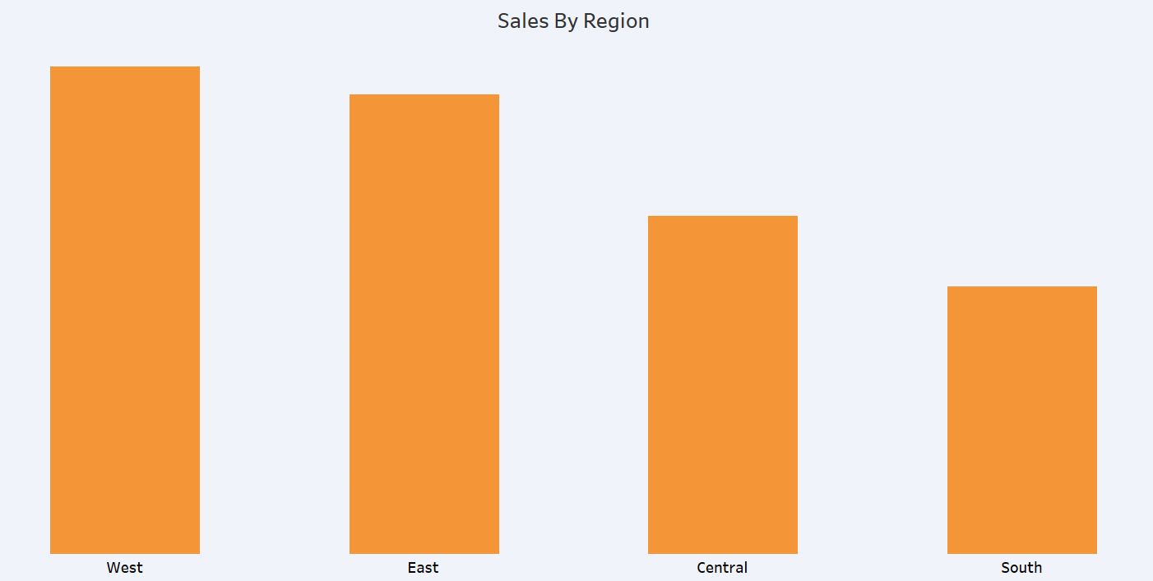

### ****Sales by Region (Bar Chart)****

**West** and **East** regions show the highest sales, while **South** lags behind.

**Insight:** There may be **market saturation or better infrastructure** in West and East. The **South region** might have untapped potential or operational barriers.

**Actionable Tip:** Explore regional marketing, partner expansion, or customer incentive programs in **South and Central** to boost their performance.